How the OptionChooser program works

When the program is first started it will look for an INI file with the same name as the OptionChooser program in the current directory.

If the file is found, it will read various settings from the file. If the settings file is not found it will use default settings that are hard coded. The program will always save the current settings to this file when it exits.

The default settings are:

[ProgramTitle]
ProgramTitle OptionChooser program caption

[OptionsDir]
OptionsDir Options directory where options stored

[About]
AboutTxtFName About.txt file name (Text document)
AboutHtmlFName file name (Html document)
AboutHttpFName file name (Http link)

[HowTo]
HowToTxtFName HowTo.txt file name (Text document)
HowToHtmlFName file name (Html document)
HowToHttpFName file name (Http link)

[Welcome]
WelcomeTxtFName Welcome.txt file name (Text document)
WelcomeHtmlFName file name (Html document)
WelcomeHttpFName file name (Http link)

[ReadMe]
DefaultReadMeTxtFName ReadMe.txt file name (Text document)
DefaultReadMeHtmlFName file name (Html document)
DefaultReadMeHttpFName file name (Http link)

[RunMe]
DefaultRunMeFName RunMe.bat file name (executable)
DefaultRunMe2FName RunMe2.bat file name always seen (executable)

[ProgramDelay]
DefaultProgramDelay 2000 millisec to wait for option to install

[Settings]
HideShell 0 hides install operations
AllowDisplayHttpLinks 1 allows display of Http links
CheckInterfaceMode 1 allows check of interface mode

[MainWindowSizes]
WindowTop 100 window top
WindowLeft 100 window left
WindowState 0 window state
WindowWidth 500 window width
WindowHeight 250 window height
OptionTreeWidth 200 option tree width

[AboutWindowSizes]
WindowWidth 200 window width
WindowHeight 200 window height

After the settings file is read the program will change window sizes, change program title, change settings menu options, populate the option tree with items from the OptionDir, and then show the window and display the contents of the Welcome file.
Menu Options

There are three menu choices across the top of the main window when it appears. The choices are File, Settings, and Help.

File Menu
The file menu has one sub item called Exit that allows you to stop the program. The program will save the current setting in the program ini file when it exists so they can be restored the next time the program starts.

Settings Menu Items
The Settings menu has two sub items called “Allow Display Http Links” and “Hide Command Window”.

- Check Interface Mode - The program has the capability to check the user.dat file at startup to see if the “Interface Mode” has been set to CUSTOM. This option is a setting the user can change to allow the program to perform this check at startup. Defaults to On.
- Allow Display Http Links - The program has the capability to display Http linked files. This option is a setting the user can change to allow the program to use their internet connection to display the files. Defaults to On.
- Hide Command Window - The program uses a shell command to run a separate executable file whenever an option is changed. This option is a setting the user can change to allow them to “watch” the executable file run when an option is being changed. Defaults to Off.

Help Menu Items
The Help menu has three sub items called HowTo, Welcome, and About.

- HowTo - Selecting this option will display the file designated by the “HowTo” file name settings in the INI file.
- Welcome - Selecting this option will display the file designated by the “Welcome” file name settings in the INI file.
- About – Selecting this option will display the file designated by the “About” file name settings in the INI file in a separate about popup window.

How an Option is Changed

The option tree on the left side of the window will show a list of all available options. When the program starts all the options in the tree will appear in a “collapsed” state. The user can double click on any of the collapsed options to expand it. Double clicking on an expanded option again will collapse it. There is a plus and minus button at the top of the option tree which can be used to collapse of expand all items in the option tree.

A small checkmark icon will appear next to each item in the tree. A green checkmark is used to represent the option that was installed when the program was last run. A light grey checkmark is used to represent an option that is NOT installed. A dark Grey checkmark is used to represent a “Default” option that is NOT installed.

To view the information associated with an option, click only on the option name and NOT the checkmark. The ReadMe file associated with the option will automatically be displayed on the right hand side of the window.

To change an option, simply left click on the checkmark and the associated RunMe file(s) will be automatically executed to change the option.

How RunMe files are used

Whenever an option is chosen from the option tree list by selecting the checkbox icon, a shell command window will open and an external executable file, determined by the RunMe file setting, linked to that option will be run. The user has the option to either enable or disable the display of the shell window by toggling the “Hide Command Window” Setting menu option.

You might sometimes want the shell window to be shown regardless of what the “Hide Command Window” setting is. This is necessary if you need the user to interact with your external application to make additional choices if necessary. Use the RunMe2 file name setting to use this feature.

How xxxFNames are used

The program has the ability to display several different types of files using either a RichEdit or WebBrowser control. The control used will be determined by the assignment of the xxxFNames in the settings files.

xxxTxtFName
If only simple text files (no graphics) are used you only need to assign a value to the xxxTxtFName and the RichEdit control will be used to display the file contents.

xxxHtmlFNames
If more complex documents (that include graphics) are used you will want to use the built in WebBrowser control to view the file. In this case assign a value to the xxxHtmlFName and the WebBrowser control will be used to display the file contents. Note that these do not have to be HTML formatted files; they just need to be files that can be viewed by the user’s current web browser. As an example they can be xxx.rtf, xxx,doc, xxx.pdf, xxx.jpg etc. filenames.

Note: Files such as RTF only will only be displayed in the program text area if windows is set to use IExplorer as the default program to view those files, otherwise the default program assigned by windows will be used.

xxxHttpFNames
It might be desirable for you to link to a file at an external website. The advantage of this is the information displayed to your user can be kept up to date. The disadvantage is it will require your user to have an internet connection to view your files. Assign a value to the xxxHttpFName and the WebBroswer control will be used to link to your file contents.

Note: When assigning values to the Txt and Html file names do not include the path. The path to the option directory will be automatically appended before the filename is displayed. For Http links, include the full web link path to the file.

How Program Delay is used

The Program Delay setting is used to create a pause or wait after an option is being changed. This causes the user to wait until the option completes the change before the next one can be selected.
How Options.ini files are used

When the user browses to a directory in the option tree list, the program will look for an option.ini file within the current directory.

If the file is found, it will read various settings from the file. If the file is not found it will use default settings read from the main program ini file. The program will always save the Mode settings to this file when the option is changed.

The default settings are:

[ReadMe]
OptionReadMeTxtFName DefaultReadMeTxtFName file name (Text document)
OptionReadMeHtmlFName DefaultReadMeHtmlFName file name (Html document)
OptionReadMeHttpFName DefaultReadMeHttpFName file name (Http link)

[RunMe]
OptionRunMeFName DefaultRunMeFName file name (executable)
OptionRunMe2FName DefaultRunMe2FName file name always seen (executable)

[ProgramDelay]
OptionProgramDelay DefaultProgramDelay millisec to wait for option to install

[Mode]
OptionMode 1 determines option icon state

[LinkChildren]
OptionLinkChildren 0 determines if “children” options linked

How Mode is used

The Mode setting is unique to this file. It is used to determine the status of the small icon located beside the option in the list. The values are:

- Hidden
- Not Available
- Unchecked
- Checked
- Unchecked default
- Checked default option
- WebPage
- Folder
- Folder open

The folder mode is determined automatically and you would not normally need to assign those values.

The Mode value of 0 can be used to prevent a subdirectory and any further contents of it from being shown in the option list. This can be used to hide things such as the “image” subdirectory sometimes associated with html files.

The Mode value of 1 is shown by the program to let you know there is no associated executable RunMe file found in the directory. This would normally only be caused by a bug in the way you setup the option. In other words, you left some files out of the directory.
How Link Children is used

The Link Children setting is also unique to the Option.ini file. It may be desired to link multiple options together. When this is done, only one of the options that are linked can be chosen at a time. By default the Link Children option is set to 0, and only the options in the same directory level or node are linked. To link a group of “child” options, set the Link Children value in the parent directory of the options to a value of 1.

When an option is changed, the program will always search backward through the option tree looking for the parent of a linked set of options. If no parent or Link Children value of 1 is found, the program will only link together the values in the current directory. If a Link Children value of 1 is found, the program will consider all the children in each subdirectories of the parent to include the current directory as linked and only allow one of them to be enabled at a time.

A picture of this concept may be worth a thousand words. In the example, the options at the top are NOT linked, so one choice for each option can be made. In the three examples at the bottom, the Chat Fonts option is defined as the parent of linked children. Because these options are each linked to Chat Fonts, only one of the choices for the Linked Children can be selected at a time.

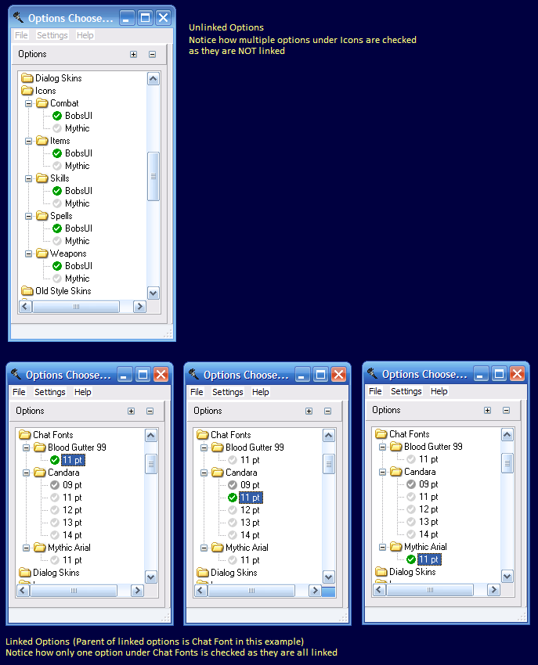
How to setup the program work to work with your own custom UI:

1) In your ui\custom directory place two files called:
OptionChooser.exe
OptionChooser.ini

The OptionChooser.exe file is the executable program. The OptionChooser.ini file is a simple text file that contains settings you can edit to alter the way the program works.

2) Create a sub directory named "Options" in the \custom directory.

3) Inside the sub directory created in step 2 place three files called:
HowTo.txt
Welcome.txt
About.txt

These files will contain the contents you want shown when the user:
a) Selects the HowTo option from the Help menu
b) Selects the Welcome Option from the Help menu or just starts the program
c) Selects the About option from the Help menu

4) Create a subdirectory within the one created in step 2 for each category of OPTIONS

5) Inside each option category created in step 4 place at a minimum three files called:
ReadMe.txt
RunMe.bat
Options.ini

Additional XML or other files as needed can be placed here.

The ReadMe.txtf file will contain the contents you want shown when the user selects the option category. The RunMe.bat file will contain the batch file commands needed to apply changes to your UI to install the option selected. The option.ini file is a simple text file that contains settings for the option located in the subdirectory.

Example of directory layout used by the program:

|---\UI\Custom
|
|---\OptionsChooser.exe (Options Chooser program)
|
|---\OptionsChooser.ini (configuration file)
|
|---\Options
|
|---\About.txt (file shown in About window)
|---\HowTo.txt (file shown when HowTo option selected
|---\Start.txt (file shown at program start)
|
|---\Artifact Table
| |---\ReadMe.txt (file shown when subdir selected)
| |
| |---\Install
| | |---\ReadMe.txt (file shown when subdir selected)
| | |---\RunMe.bat (batch file ran when option is selected)
| | |---\option.ini (settings file for this option choice)
| |
| |---\Uninstall
| |---\ReadMe.txt (file shown when subdir selected)
| |---\RunMe.bat (batch file ran when option is selected)
| |---\Option.ini (settings file for this option choice)
|
|---\ToolTips
|---\ReadMe.txt (file shown when subdir selected)
|
|---\Install
| |---\ReadMe.txt (file shown when subdir selected)
| |---\RunMe.bat (batch file ran when option is selected)
| |---\Option.ini (settings file for this option choice)
|
|---\Uninstall
|---\ReadMe.txt (file shown when subdir selected)
|---\RunMe.bat (batch file ran when option is selected)
|---\Option.ini (settings file for this option choice)

Note: You can place an Option.ini file in the parent directories, such as UI/Custom/Options/ToolTips to control how the ReadMe file is displayed when that option is selected. You can also use the file to Link Children options together that are located in multiple subdirectories.

